Shred Recipes Volume 4

Pork Belly

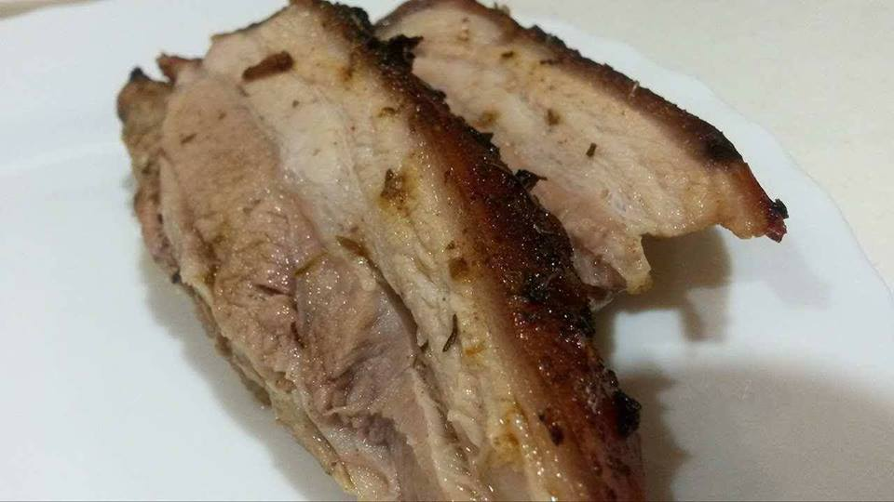

Serves 4

Ingredients

1 kg of pork belly (get the butcher to score it!)
2 cloves garlic crushed
1/4 cup coconut oil
1 tbsp. pink Himalayan salt (and extra)
1 tbsp. ground coriander
1 tbsp. dried thyme leaves
1 tbsp. paprika
1 tsp. onion powder
1 tsp. chilli powder

Directions

Preheat the oven to 220*C.
In a small bowl combine all the herbs, spices and garlic.
Place the pork belly skin side up in a greased roasting pan.
Pour over half the oil and season really well with salt.
Sprinkle the spice mix over and rub it in to the pork skin, make sure you get the spice mix into those scores!
Pour over the remaining oil and season with a little extra salt.
Place the pork into the oven for 20 minutes, watch that skin puff and crisp up!
Turn down the oven to 160*C and cook for a further 1 hour.
If the skin isn't quite crisp enough (boohoo!) place under a hot grill for 5-10 minutes.
Allow the pork to rest for 10 minutes before cutting and serving!

Cauliflower Rice

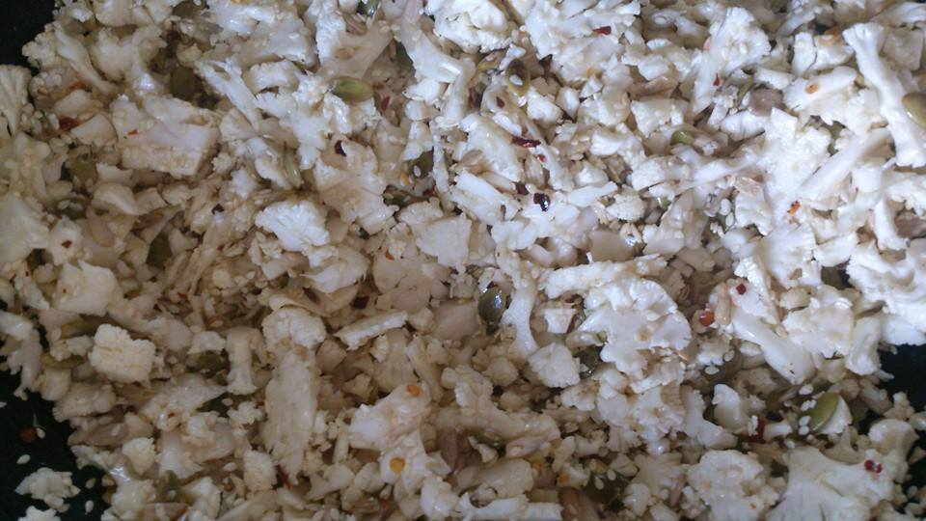

Serves: 3-4

Ingredients

1 head cauliflower
1 tbsp ghee
1 medium sized avocado
1 cup basil leaves, loosely packed
2 tbsp lemon juice
4 tbsp olive oil
¼ cup water
Salt and pepper to taste
Sprinkle 1 or 2 palmfuls of Cashew nuts over your dish for protein.

Directions

Chop cauliflower into florets and place in food processor.
Pulse until cauliflower is broken up into rice sized pieces.

Heat a large skillet over medium-high heat and melt ghee.

Pour cauliflower rice into the skillet; add a pinch of salt and pepper, and sauté until cauliflower is cooked, about 8-10 minutes.

Meanwhile, place avocado, basil, olive oil, 1/4-cup water and lemon juice in food processor.
Puree until smooth, adding salt and pepper to taste.

Once cauliflower rice is cooked, remove from heat and pour avocado mixture into skillet.

Stir to combine and serve.

Add the cashew nuts.

Shepherd’s Pie

Serves: 4-6

Ingredients

2 tbsp coconut oil
1 medium yellow onion, diced
500g pork bacon, cut into 4cm slices
2 cups diced carrots
2 cups diced celery
500g organic grass fed ground beef (can also use lamb or turkey)
½ tsp. celtic sea salt
1 tsp. ground black pepper
½ tsp. smoked paprika
1 cup chicken broth
2 large heads cauliflower, trimmed, chopped and steamed until very soft
2 tbsp ghee or coconut oil

Note: You could omit the bacon or use less and increase the ground meat to 1kg.

Directions

Pre-heat oven to 175*C

Heat coconut oil in a very large frying pan. Sauté onion for 8-10 minutes until soft.
Add bacon pieces to pan and sauté until cooked, about 10 minutes.

Add carrots and celery to pan and sauté in bacon fat for 10 minutes until soft.
- Add ground beef to pan and sauté until brown. Season with salt, pepper and smoked paprika.

Add chicken broth and cook down broth until about half of it is evaporated.

Pour ground beef mixture into a 23 x 33cm baking dish.

Place cauliflower in food processor and puree with ghee until smooth. Pour mashed cauliflower over beef mixture.

Bake at 175*C for 30 minutes.

Raw Brownie Balls

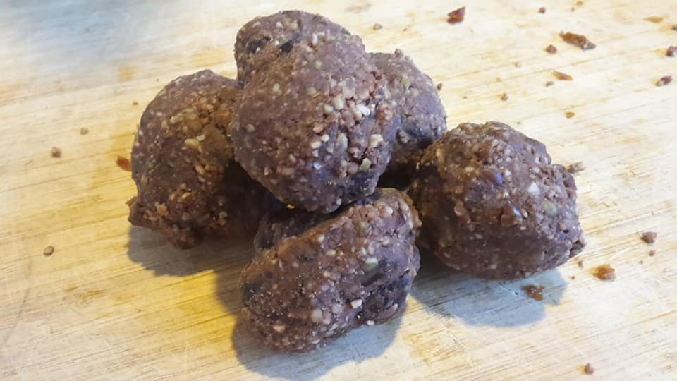

The measurements are different depending on your taste buds, so give it the taste test as you go. I like my bliss balls with less sugar personally.

1 to 2 cups of dates
Up to ½ cup of cacao powder
2 to 3 cups of nuts & seeds (walnuts & almonds work well, but you can use others)

Ground nuts & seeds and cacao powder into a crumb like texture in your processer.
Add chopped dates and process until the mixture becomes oily and crumbly.
Roll small handfuls into balls and keep in cupboard.

Chicken Soup

Chicken soups are an awesome way to boost immunity, heal your gut and increase calcium. Use a carcass left over from a roast. They are simple and versatile. Make this soup in a large quantity and freeze some portions for work lunches. Don’t worry if you don’t have the ingredients listed below, just use what you’ve got.

Ingredients

3 or 4 gloves of garlic
Chicken carcass
Pumpkin (seeded, skin removed)
Carrots (chopped unpeeled)
Kumara (chopped & peeled)
Broccoli
Cabbage
Gluten Free Chicken Stock
Salt & Pepper

Directions

Place a free range chicken carcass into a large pot and bring to the boil. Prepare vegetables.
Reduce the temperature to a medium heat and keep a rolling boil for 30 minutes.
Place your kumara, pumpkin, carrots, garlic, chicken stock, salt & pepper into the pot.
After about 30 minutes place your softer vegetables like broccoli and cabbage into the pot and cook for a further 30 minutes.
Serve in a nice big bowl

Ginger Garlic Chicken

Serves: 3-4

Ingredients

1 tbsp ghee
Sea salt & black pepper to taste
6 bone-in, skin-on chicken thighs
1 small onion, finely sliced
2 cloves of garlic, minced or grated
1/2 tsp. ginger powder or fresh ginger
1-2 pinches chili flakes
1/4-cup coconut aminos

Directions

Preheat the oven to 220*C

In an oven safe cast iron or stainless steel skillet, melt the ghee, then season both sides of the chicken with sea salt and black pepper, and place skin side down into the pan for 5-6 minutes or until the skin browns.

While the chicken cooks, combine the onion, garlic, ginger, chili flakes, coconut aminos and more sea salt and black pepper in a small mixing bowl.

Flip the chicken thighs over so that they are now skin side up in the pan, then pour the sauce mixture over the chicken evenly and place the pan into the oven for 30 minutes.

Stir Fry Beef

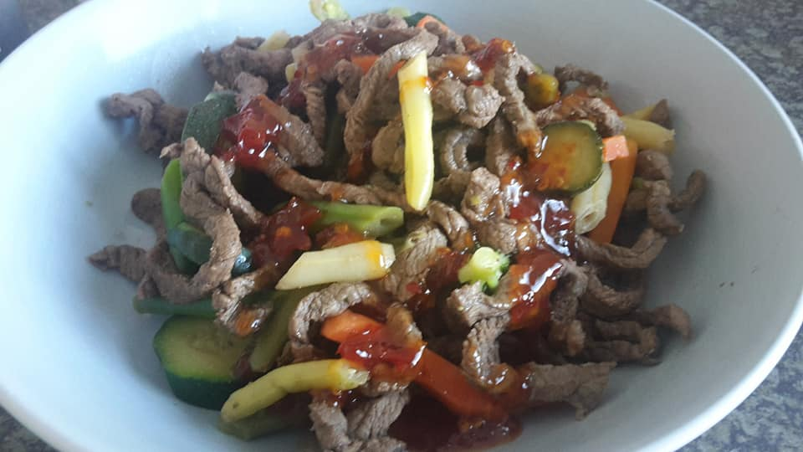

Ingredients

500g stir fry beef strips
2 tbsp balsamic vinegar
2 tbsp dark soy sauce
2 tbsp Worcestershire sauce
Small bunch spring onions, sliced on diagonal
200g roasted antipasto peppers in oil or vinegar, drained or sliced
Cooked mixed veges, to serve (bags of pre-prepared frozen veges are quick and easy)

Directions

Marinate the beef. Put the beef in a medium, non-metallic bowl and cover with the vinegar, soy and Worcestershire sauce. Leave to marinate for 20 minutes, or if you have the time, overnight.

Stir fry. Heat a small dry wok until it’s very hot. Tip in the beef, marinade and spring onions, stir fry for 2 minutes. Add the roasted peppers then stir fry for a further 2 minutes. Divide the stir fry between shallow bowls and serve with cooked mixed vegetables.

Raw Apple or Feijoa Crumble

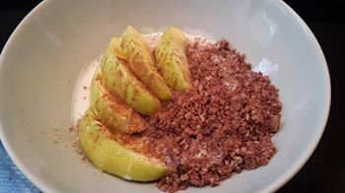

Serves 1

Ingredients

½ apple, skin on, sliced
2 closed palmfuls nuts and seeds, ground down to a crumb / biscuit texture
½ tsp cinnamon
1 tsp maple syrup
Drizzle coconut milk
1 tbsp coconut yoghurt (optional)

Directions

Place apple slices in a bowl, sprinkle ground nuts and seeds on top.
Sprinkle on cinnamon.
Drizzle coconut milk over top.
Heat in microwave for 40 seconds on high.
Add maple syrup and coconut yoghurt.

Gluten Free Banana Pancake

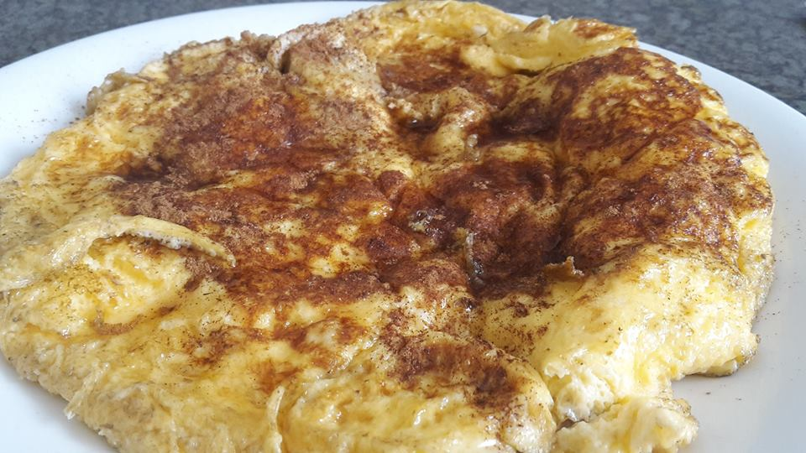

Serves 1

Ingredients

2 eggs females/3 eggs for males
Dash of milk
1/2 bobby banana
Sprinkle of maple syrup
Sprinkle of cinnamon
1 to 2 TBLS of Coconut Yoghurt

Directions

Place coconut oil in a pan. Whisk eggs and milk together and pour into the frying pan. Slice the banana over the egg as it cooks. Flip over and cook the other side until egg is cooked through. Place on a plate and sprinkle cinnamon and maple syrup over the pancake. Top with coconut yoghurt.

Note: It may pay to cook the batch up in two or three separate pancakes for ease of flipping during cooking.

Buddha Bowl palmful chicken

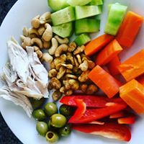

Serves 4

This is a very versatile and convenient dish to prepare. Replace eggs with a palmful of animal/fish protein and change vegetables for whatever you have in your fridge & pantry. If you don’t feel like cooking, then just use a combination of cold & raw foods. Easy.

If your goal is weight loss, be mindful of Kumara portion size.

Ingredients

3 to 4 cups of chopped kumara & pumpkin OR boil 2 Corn cobbs 6 eggs hardboiled ½ walnuts Olive oil Cumin Oregano Any optional veges you want (see below).

Chop half a butternut pumpkin and two Kumara into cubes. Pop onto a roasting tray. Drizzle with olive oil, 1 tsp cumin and 1 tsp oregano and cook at 180C for 20 minutes. For the last five minutes add ½ cup of walnuts to the pan and roast. Hard boil six eggs.

Place eggs and a handful of pumpkin & Kumara to a bowl. Add your choice of chopped vegetables like kale, spinach, tomatoes, cucumber, lettuce, peppers steamed broccoli etc.

Sprinkle walnuts across the veges & eggs, and drizzle with olive oil. Season well.

2 egg breakfast scramble

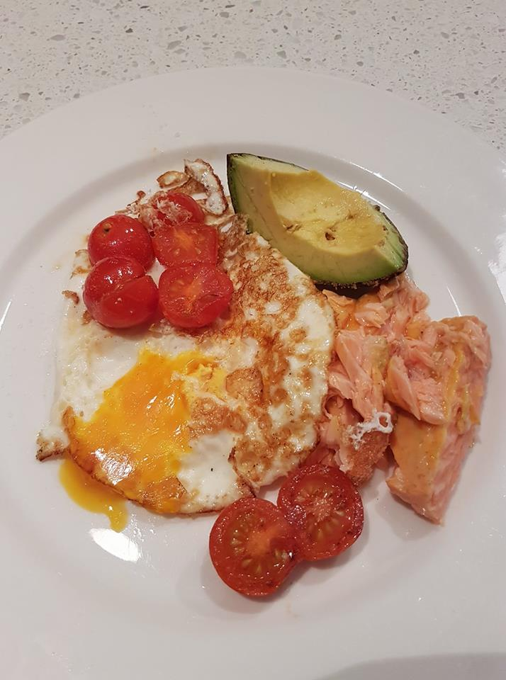

Serves 1

Ingredients/Directions

Fry or scramble a couple of eggs and add unlimited veges like mushrooms, tomatoes, courgettes etc. I even add half a banana to the pan and fry that too or a ¼ of an avocado.

This is meant to be very easy meal!

Poached Eggs, Spinach, Salmon

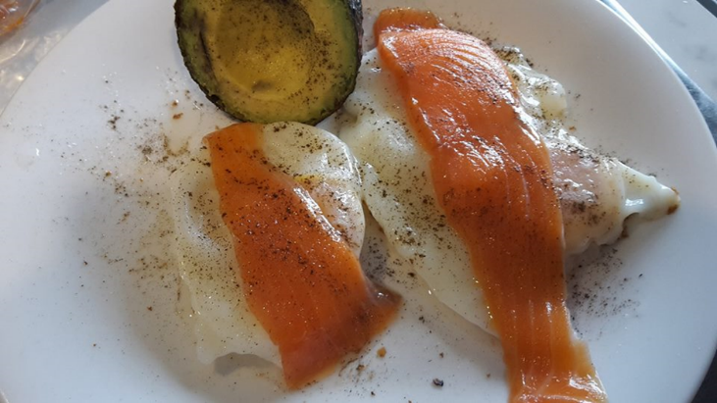

2 or 3 eggs
A few Salmon strips
Bunch of spinach
Optional extra veges

Poach the eggs and spinach in a pan of boiling water. Remove the spinach and eggs when the eggs are cooked. Place the spinach on the plate and on top place the eggs. Lay the strips of salmon across the eggs and season.

